**Comparing Quantities**

# Ratio and percentage

* + Ratio means comparing two quantities with each other.
  + Percentages are numerators of fractions with denominator 100. The symbol '%' is used for percent

and it indicates multiplication with 1 .

100

# Increase or decrease percentage

Percentage increase/decrease =

Amount of change  100% Original amount

# Cost price (C.P.) and selling price (S.P.)

* + The price at which an article is purchased is called the cost price (CP).
  + The price at which an article is sold is called the selling price (SP).

# Discount

In order to give a boost to the sales of an item or to clear the old stock, articles are sold at reduced prices. This reduction is given on the Marked Price (MP) of the article and is known as discount.

* + Discount = MP – SP
  + Discount % = MP  SP 100

MP

* + S.P  M.P. 100  Discount% 

 100 

* + M.P. 

 

100  S.P.

100  Discount%

# Estimation in percentage

In case, discount is given on the MP of an article which a decimal quantity, try to round off it to the nearest tens. Apply the discount on the rounded number to get the final amount to be paid.

# If SP > CP, then the profit is made and it is evaluated as follows:

* + Gain = (SP) – (CP)

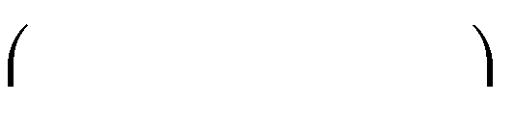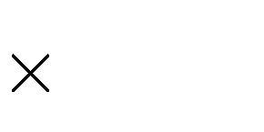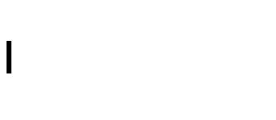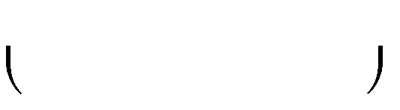

Gain 100 CP

* + Gain% =
  + S.P  C.P. 100  Gain% 

 100 

* + C.P. 

 

100  S.P.

100  Gain%

# If SP < CP, then a loss is incurred and it is evaluated as follows:

* + Loss = (CP) – (SP)

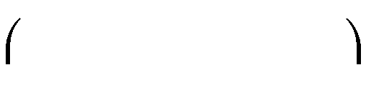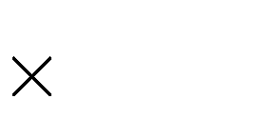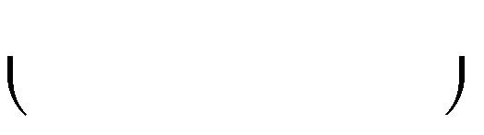

Loss 100 C.P.

* + Loss% =
  + S.P  C.P. 100  Loss% 

 100 

* + C.P. 

 

100  S.P.

100  Loss%

# Sales tax/Value added tax (VAT)/Goods and services tax (GST)

* + Sales tax or value added tax (VAT) is charged on the sale of an item by the government and is added to the Bill Amount. It is collected by the retailer when the final sale in the supply chain is reached from the end consumer and given to the government.

Sales tax = Tax% of Bill Amount

* + VAT is collected by all sellers at each stage of the supply chain.
  + GST is introduced from July 1, 2017 by the Government of India which is levied on the supply of goods or services or both.

# Interest and Principal

* + Whenever we borrow money from some lending sources such as banks or financial institutions etc., we have to pay some extra money for the service of lending.
  + This extra money depends on the sum and the period of time and this extra money is called the interest.
  + The money borrowed is called the principal or sum.
  + Amount = (principal + interest).
  + Interest on 100 for 1 year is called the rate per cent per annum.

# Simple Interest

* + If the interest is calculated uniformly on the original principal, it is called the simple interest.
  + If P, R, T stand for principal, rate and time respectively, and SI stands for simple interest, then

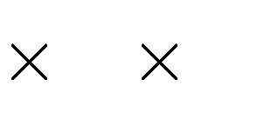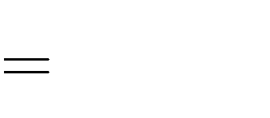

P R T

100

SI

# Compound interest

* + Compound interest is the interest calculated on the previous year’s amount.

# Conversion period

The time period after which the interest is added each time to form a new principal is called the

# conversion period.

* + Amount when interest is **compounded annually** is given by

 R n

A = P 1  100 

 

; P is principal, R is rate of interest, n is time period

* + When the interest is **compounded half yearly**, there are two conversion periods in a year each after 6 months. The rate of interest in such situations is half of the annual rate.
  + Amount when interest is **compounded half yearly** is
  + Compound Interest is given as

 R nk 

C.I = A – P = P 1  

100k

 

* 1 , where the interest is compounded k times in a year, P be the



principal and the R be the rate of interest per annum.

# Compound interest for n years

Let P be the principal and the rate of interest be R1% for first year, R2% for second year, R3% for third year and so on and Rn% for nth year. Then the amount A and the compound interest C.I at the end of n years are given by

A  P 1 

R1  1 

R2 ...1 

Rn 

 100  

100  

100 

     

# Applications of Compound Interest formula

There are many situations where the formula for the calculation of amount in compound interest is used. Some situations are listed below:

1. Increase or decrease in population.
2. The growth of a bacteria if the rate of growth is known.
3. The value of an item, if its price increases or decreases in the immediate years.

# Compound Interest formula in Population

* + Let P be the population of a city or town at the beginning of a certain year and the population grows at a constant rate of R% per annum, then

 R n

Population after n years=P 1+100 

 

* + Let P be the population of a city or town at the beginning of a certain year. If the population grows at a constant rate of R1% during the first year and R2% during the second year, then

Population after 2 years=P 1+ R1

  1+ R2 

 100  

100 

   

* + Let P be the population of a city or town at the beginning of a certain year. If the population decreases at a constant rate of R% per annum, then

 R n

Population after n years=P 1  100 

 

•

# Compound Interest formula in Depreciation

* + Depreciation means reduction of price due to use and age of an item. If by any reason, the price goes up, we call it appreciation.

 r n

* + In case of depreciation, the formula used is:

 

A  P 1  100 

 r n

* + In case of appreciation, the formula used is:

 

A  P 1  100 